REGULAR ARTICLE

TITLE OF MANUSCRIPT (BOLD, 12 TIME NEW ROMAN, CENTER)

Please note, that only those submitted article will be reviewed - prepared according to the Authors’ RAAE guidelines and instructions below.
Since the RAAE run double-blinded review of submitted articles, please remove all authors’ personal information from manuscript text.

ABSTRACT

Text (normal, 10 Times new roman, full aligned, min 250 max 350 words. Abstract should summarize the main sections of your manuscript, particularly your principal findings and your study limitations.
It should outline shortly the motivation for the research and research background. In the abstract, the purpose of the article, method of the research, data, outline of results and main contribution must be given according to the bellow given format (Times New Roman, 10 pt, fully justified, line spacing single).

Research background: Abstract, Abstract, Abstract, Abstract, Abstract, Abstract, Abstract, Abstract, Abstract, Abstract, Abstract, Abstract, Abstract, Abstract.

Purpose of the article: Abstract, Abstract, Abstract, Abstract, Abstract, Abstract, Abstract, Abstract, Abstract, Abstract, Abstract, Abstract, Abstract, Abstract.

Methods: Abstract, Abstract, Abstract, Abstract, Abstract, Abstract, Abstract, Abstract, Abstract, Abstract, Abstract, Abstract, Abstract, Abstract.

Findings, Value added & Novelty: Abstract, Abstract, Abstract, Abstract, Abstract, Abstract, Abstract, Abstract, Abstract, Abstract, Abstract, Abstract, Abstract.

Keywords: max 5 keywords; separated with semicolon; Times New Roman, 10 pt, italics, left justified
JEL Codes: R52; R58; H41 (Times New Roman, 10 pt, left justified, separated with semicolon, JEL available at: http://www.aeaweb.org/jel/jel_class_system.php#A )

Please use normal, 10 pt Times New Roman, full aligned, spacing 0, line spacing single.

LENGTH OF THE MANUSCRIPT
The minimum length of the manuscript is 21 000 characters with spaces. Papers that are shorter than 21 000 characters will not be transferred to the review process. The maximum length of article is 35 thousand characters with spaces.

THE SUGGESTED SCHEME OF ARTICLE
Body of the submitted paper, consisting of parts corresponding with steps of accomplishment of the article aims, should be divided into following sections: Introduction / Literature review / Research methodology / Results / Discussions / Conclusions
The article submitted to RAAE for publication should have separate methodological paragraph, located behind the Literature review. In this paragraph the author should describe precisely the methods of the research.

INTRODUCTION

The introduction should be brief and must clearly state the question that you tried to answer in the study. A review of the literature must not appear in the introduction. Only cite those references that are essential to justify your proposed study. Text (normal, 10 Times New Roman, full aligned) for example: Text (Herrera et al., 2010). Text (Green, 2003; Rault, Sova & Sova, 2009). Fidrmuc, Hubert & Michalek (1999) note that in recent years, text…
The objective of our study was (your research) ..

The introductory paragraph outlines clearly the objectives and motivation for writing the paper. The introduction should provide a context for the discussion in the body of the paper and point explicitly the purpose of the article.
The checklist:
- The introduction includes the justification for the topic importance.
- The introduction section includes the aim/objective.
- The introduction section includes brief information on methods.
- The content of each section of the article is briefly described in the last paragraph of the introduction.

LITERATURE REVIEW

The checklist:
- Is the literature review properly prepared?
- Is primary literature correctly summarized?
- The literature review shows who dealt with similar research topic before?
- The literature review shows what are the results of the prior studies?
- Did the Author position himself/herself among the previous researchers?
- Are different options/perspectives from the literature covered in the reviewed article?
- The difference with existing studies is explicitly identified and documented.
- The text includes references whenever necessary.

RESEARCH METHODOLOGY

Subheadings should be used (bold 10 Times new roman, italics)
The main purposes of this section are to describe and defend the methods selected and to provide sufficient details, so that a competent worker can repeat the study. If standard methods of measurement are used, then appropriate references are all that is required. In many instances "modifications" of published methods are used and it is these that cause difficulties for other workers. To ensure reproducible data, authors should:
- Give complete details of any new methods used.
- Give the precision of the measurements undertaken.
- Use statistical analysis sensibly.
Text (normal, 10 Times new roman, full aligned) should be complete enough to allow studies to be reproduced. However, only truly new procedures should be described in detail; previously published procedures should be cited, and important modifications of published procedures should be mentioned briefly. Methods in general use need not be described in detail text.
Number equations consecutively with equation numbers in parentheses flush with the right margin, as in Eq. (1). Use the WORD equation editor to create the equation and mathematical notation (Eq. 1).

$T_{i}=α+βA_{i}+γ_{1}X_{1,i}+…+γ_{M}X_{M,i}+ε_{T_{i,i}}$ (1)

The equations need to be numbered and all Equations must be referenced in the article text. Use numbers in thin brackets on the right side. Use the references to all equations (Eq. 2) in the manuscript text.

$T_{i}=α+βA_{i}+γ_{1}X_{1,i}+…+γ_{M}X_{M,i}+ε_{T_{i,i}}$ (2)

We recommend using MS Word's integrated equation editor. Menu, Insert, Equation (Eq. 3).

$T_{i}=α+βA_{i}+γ_{1}X_{1,i}+…+γ_{M}X_{M,i}+ε_{T_{i,i}}$ (3)

Be sure that the symbols in your equation have been defined before the equation appears or immediately following.

This section is compulsory and it should provide specific description of the methodology.
The checklist:
- The research methodology section includes the description of the material selection.
- The research methodology section includes: the hypothesis/es.
- The research methodology section includes the description of the research methods.
- The article identifies strengths and weaknesses of the methodology and its findings.

RESULTS

Subheadings should be used (bold 10 Times new roman, Italics)
Text (normal, 10 Times new roman, full aligned). Results should be presented with clarity and precision. The results should be written in the past tense when describing findings in the author(s)’s experiments. Previously published findings should be written in the present tense. Results should be explained, but largely without referring to the literature. Tables and figure are including in the text.
Research on rural multifunctionality may be undertaken from either the supply (provision) or demand perspective, as shown in Figure 1 (OECD, 2001, 2003).
Text ……….. (normal, 10 Times new roman, full aligned) ……….. Text ……….. (normal, 10 Times new roman, full aligned) ……….. Text ……….. (normal, 10 Times new roman, full aligned) ……….. Text ……….. (normal, 10 Times new roman, full aligned) ……….. Text ……….. (normal, 10 Times new roman, full aligned) ……….. Text ……….. (normal, 10 Times new roman, full aligned) ……….. Text ……….. (normal, 10 Times new roman, full aligned) ………..Text (normal, 10 Times new roman, full aligned) ……….. Text ……….. (normal, 10 Times new roman, full aligned) ………..

Figures have to be included in an editable format (Figure 1). Do not use a picture format.

Figure 1. The mobility indices of RCA, 1996-2015, by country, percentage
Source: Own computation based on WITS (2016) data, Times New Roman, 9 pt

Place text or data in separate cells of table (Table 1)

Table 1 Descriptive statistics
Variables | Sample mean | Std. deviation | Min | Max
Teff in kg | 417.13 | 712.97 | 0 | 12,951.86
Wheat in kg | 204.26 | 529.21 | 0 | 13,288.70
Sorghum in kg | 227.73 | 658.67 | 0 | 8,653.87
Barley in kg | 103.18 | 347.64 | 0 | 7,321.25
Land in hectares (ha) | 1.23 | 2.17 | 0.02 | 20.68
Labour (number of working-age family members) | 5.30 | 2.09 | 1 | 16.00
Oxen (number) | 1.55 | 1.413 | 1 | 5.99
Fertiliser in kg | 28.43 | 51.03 | 0 | 411.45
Manure in kg | 91.30 | 144.27 | 0 | 496.00
Other crops in kg | 613.90 | 780.24 | 6.64 | 12,951.86
Plot slope (proportion of plots with flat slope) | 0.27 | 0.32 | 0 | 1
Plot fertility (proportion of plots with fertile soil) | 0.39 | 0.37 | 0 | 1
Note: Times New Roman, 9 pt

Text ……….. (normal, 10 Times new roman, full aligned) ……….. Text ……….. (normal, 10 Times new roman, full aligned) ……….. Text ……….. (normal, 10 Times new roman, full aligned) ……….. Text ……….. (normal, 10 Times new roman, full aligned) ……….. Text
text. Descriptive statistics on the variables used in our analysis are presented in Table 1. All Tables and Figures have to be explained and referenced in the article text (Table 2).
Discussion, speculation and detailed interpretation of data should not be included in the results but should be put into the discussion section. The Discussion should interpret the findings in view of the results obtained in this and in past studies on this topic. State the conclusions in a few sentences at the end of the paper. The Results and Discussion sections can include subheadings, and when appropriate, both sections can be combined.

The checklist:
- Are the results discussed in details?
- Is the research problem original and a kind of novelty?
- Is the reasoning sound?
- Has the Author given the appropriate interpretation of the data and references?
- Are the pieces of information used inside the paper comes from reliable sources?

DISCUSSION

The checklist:
- The article assesses and critiques the findings and/or the statistical analysis.
- Are the findings in the article compared to findings of other authors?
CONCLUSIONS

Text ……….. (normal, 10 Times new roman, full aligned) ……….. The conclusion should include the most important idea of the experiment, the author's own findings, possible solutions to the problem, recommendations for further research, etc.
It should provide a neat summary and possible directions of future research.
The checklist:
- Does this part include the general summary of the article, its results and findings?
- Does this part include implications and recommendations for practice?
- Does this part include research limitations?
- Does this part include suggestions for future research?

Acknowledgments: of people, grants, funds, etc. should be brief.

REFERENCES

This section should contain list of all publications that the author referred to (Times New Roman, 10 pt).
Please adjust references using the APA 7th citation and referencing format
Please do not use any predefined text style.
Please complete all sources with DOI, including active hyperlinks.

The checklist:
- The bibliography includes more than 10 scientific references.
- The bibliography includes at least 5 references indexed in Web of Science.
- All the references are written in English.
- All the references must be up to the APA style and DOI system.
- In the list of bibliography positions only the first word of the titles is written with capital letter.

In every article minimum 5 references have to be from Web of Science Database.
Only references to literature in English language should be made in the article.

Title references to any material that has been provided by a previous authors, or been published in another source should be set in harmonization with Harvard norms – precisely APA styles (American Psychological Association 7th edition – more information on
http://www.apastyle.org/;
https://www.usq.edu.au/library/referencing/apa-referencing-guide ;
https://usq.pressbooks.pub/apa7/ ).
The authors may use automatic citation maker for citation and references: automatic APA citation maker. (http://citationmachine.net/index2.php?reqstyleid=2&newstyle=2&stylebox=2 ).

The following references to literature may be used in main text:
- a surname of an author of a work, coma, the year of edition, comma number of pages in brackets, for example: (Romer, 1985, pp. 998-1020), (Romer, 1985, p. 999),
- publication by two authors – a surname of the first author & a surname of the second author, comma, the year of edition, coma number of pages in brackets, for example: (Poon and Granger, 2003, pp. 23-49),
- if a joint publication is quoted, for example: (Snowdon (Ed.), 1998, pp. 100-121),
- if there are more than two editors or authors for example (Snowdon et al., 1998, pp. 100-121; Taylor et al., 2018)

The exemplary fragment of text:
The analyses concerning financial market in Poland with application of GARCH model have been carried out by Ciaian (2013), Snowdon et al. (1998); Doman and Doman (2014, pp. 998-1020), Fiszeder (2014a, 2014b, 2015) and Fidrmuc et al. (2016, pp. 998-1020).

A list of literature should be placed at the end of the manuscript. In the case of the title of bibliography item only the first word of the tile should be written in capital letters. Literature items should be arranged alphabetically by surname of an author and set in Times New Roman 10 pt, by following format:

- Books - a surname, an initial of an author’s first name (year of edition). the title of a work (in italics). a place of edition: the name of a publisher.

Examples:
HENDRY, D. F. (2000). Econometrics: alchemy or science? Oxford: Oxford University Press.
BARO, K. (2000). Microeconomics. New York: New York University Press.

- Chapters in Books (composite authors) – a surname, an initial of an author’s first name (year of publication), the title of a chapter. In an initial of an editor’s first name a surname (Ed(s)), the title of a work. a place of edition: the name of a publisher.

Examples:
MIZON, G. E. (1995). Progressive modelling of macroeconomic time series: the LSE methodology. In K. D. Hoover & G. MIZON (Eds.). Macroeconomics: Developments, Tensions and Prospects. Dordrecht: Kluver Academic Press.

- Periodicals – a surname, an initial of an author’s first name (year of edition). the title of a article. the title of periodical (in italics), number of volume (in italics), number of periodical.

Examples:
FARRELL, M. J. (1957). The measurement of productive efficiency. Journal of the Royal Statistical Society, 120(3), 253-290. https://doi.org/10.2307/2343100
NELSON, C. R., PLOSSER, C. I., & GRANGER, C. (1982). Trends and random walks in macroeconomic time series. Journal of Monetary Economics, 10(3).

- Websites – a surname, an initial of an author’s first name (year of edition). the title of a work. Retrieved from http://address.

Examples:
WALKER, A. (2019). Germany avoids recession but growth remains weak. BBC News. https://www.bbc.com/news/business-50419127
HILLMAN, K. (2005). The first year experience: The transition from secondary school to university and TAFE in Australia (Research Report 40). Australian Council for Educational Research. https://research.acer.edu.au/cgi/viewcontent.cgi?article=1043&context=lsay_research

How to find DOI

As the publisher of the journal is a member of Crossref and journal has DOI number (which influences positively the citation of the articles published) the authors are obliged to prepare their references in a form that fulfil the criteria of the DOI system. The author must check all the articles that are included in the bibliography of the submitted paper whether the articles cited have DOI numbers. One should use for this purpose:

http://www.crossref.org/guestquery/ .

When the author prepares references of the submitted paper, one should check each one cited article and use for this purpose at least First Author and Article Title. The print screen of the DOI website is available below.

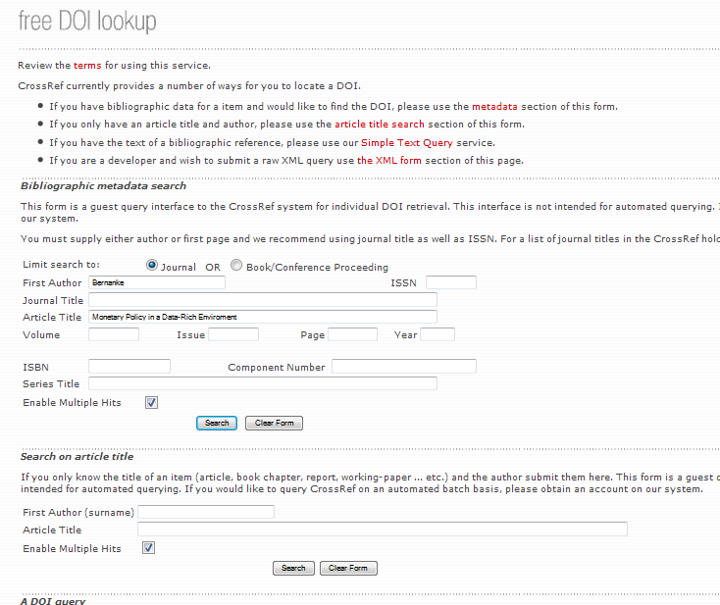

When a given article has the DOI number it should be added in the end in the bibliography. The print screen of the DOI website with the article with DOI number is available below.

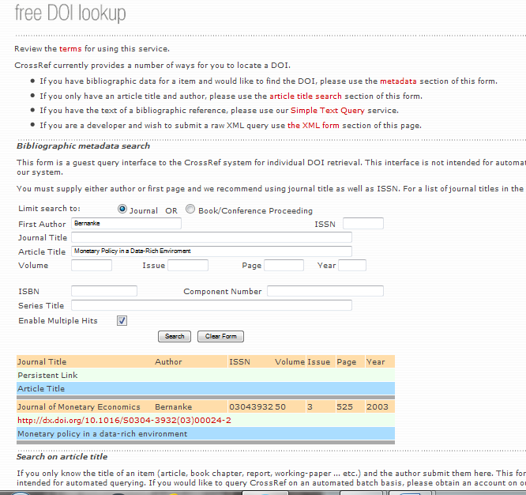

Example of the References with and without DOI:

REFERENCES

BARRO, K. (2000). Microeconomics. New York: New York University Press.
BERNANKE, B., & BOIVIN, J. (2010). Monetary policy in a data-rich environment. Journal of Monetary Economics, 50(3). http://dx.doi.org/10.1016/S0304-3932(03)00024-2
CHARNESS, G., & RUSTICHINI, A. (2011). Gender differences in cooperation with group membership. Games and Economic Behaviour, 72(1), 77-85. http://dx.doi.org/10.1016/j.geb.2010.07.006
CHARYULU, D. K. & BISWAS, S. (2010). Economics and efficiency of organic farming vis-à-vis conventional farming in India. Indian Institute of Management Ahmedabad-380 015, India. W.P. No. 2010-04-03, April 2010.
COELLI, T. J. (1995). Estimators and hypothesis tests for a stochastic frontier function: A Monte Carlo analysis. Journal of Productivity Analysis, 6, 247–268. http://link.springer.com/article/10.1007/BF01076978
COOK, M. L., & CHADDAD, F.R. (2004). Redesigning cooperative boundaries: the emergence of new models. American Journal of Agricultural Economics, 86(5), 1249-53. https://doi.org/10.1111/j.0002-9092.2004.00673.x
CROSS, S. E., & MADSON, L. (1997). Models of the self: self-construals and gender. Psychological Bulletin, 122(1).
FARRELL, M. J. (1957). The measurement of productive efficiency. Journal of the Royal Statistical Society, 120(3), 253-290. https://doi.org/10.2307/2343100
HENDRY, D. F. (2000). Econometrics: alchemy or science? Oxford: Oxford University Press.
http://dx.doi.org/10.1037/0033-2909.122.1.5
MIZON, G. E. (1995). Progressive modelling of macroeconomic time series: the LSE methodology. In K. D. Hoover (Ed.). Macroeconomics: developments, tensions and prospects. Dordrecht: Kluver Academic Press.
POON, S. H., & GRANGER, C. (2003). Forecasting volatility in financial markets: a review. Journal of Economic Literature, 19(1). http://dx.doi.org/10.1257/002205762743
TZOUVELEKAS, V., PANTZIOS, C. J., & FOTOPOULUS, C. (2002a). Technical efficiency of alternative farming systems: the case of Greek organic and conventional olive–growing farms. Food Policy, 26(6), 549–69. http://dx.doi.org/10.1016/S0306-9192(01)00007-0
ZIMMER, D. M. (2015). Analyzing co-movements in housing prices using vine copulas. Economic Inquiry, 53(2), 1156-1169. http://onlinelibrary.wiley.com/doi/10.1111/ecin.12156/abstract

